
PRODUCT SPECIFICATION
Functional and technical specification for the MyThuso platform — patient, nurse, doctor, partner and operations products, AI, devices and integrations
Version 1.0 · September 2026 · Confidential
Gilbert Makinana — Founder, MyThuso
Built by Akhanya IT Innovations (Pty) Ltd

Contents

1. Purpose and scope
This document specifies what the MyThuso platform does, for whom, and how it is built. It covers the five user-facing products (Patient & Family app, Nurse app, Doctor app, Partner portal, Control Tower), the platform services behind them (dispatch, Thuso AI, Health Passport, payments and plans, messaging, device hub, enterprise back office, analytics), the device and wearable integrations, data, security and compliance requirements, the technology stack, the phased delivery plan and a list of recommended additional features. Phase tags: 1 = launch MVP (months 1–5), 2 = months 6–9, 3 = months 10–12, 4 = months 13–18, 5 = beyond.
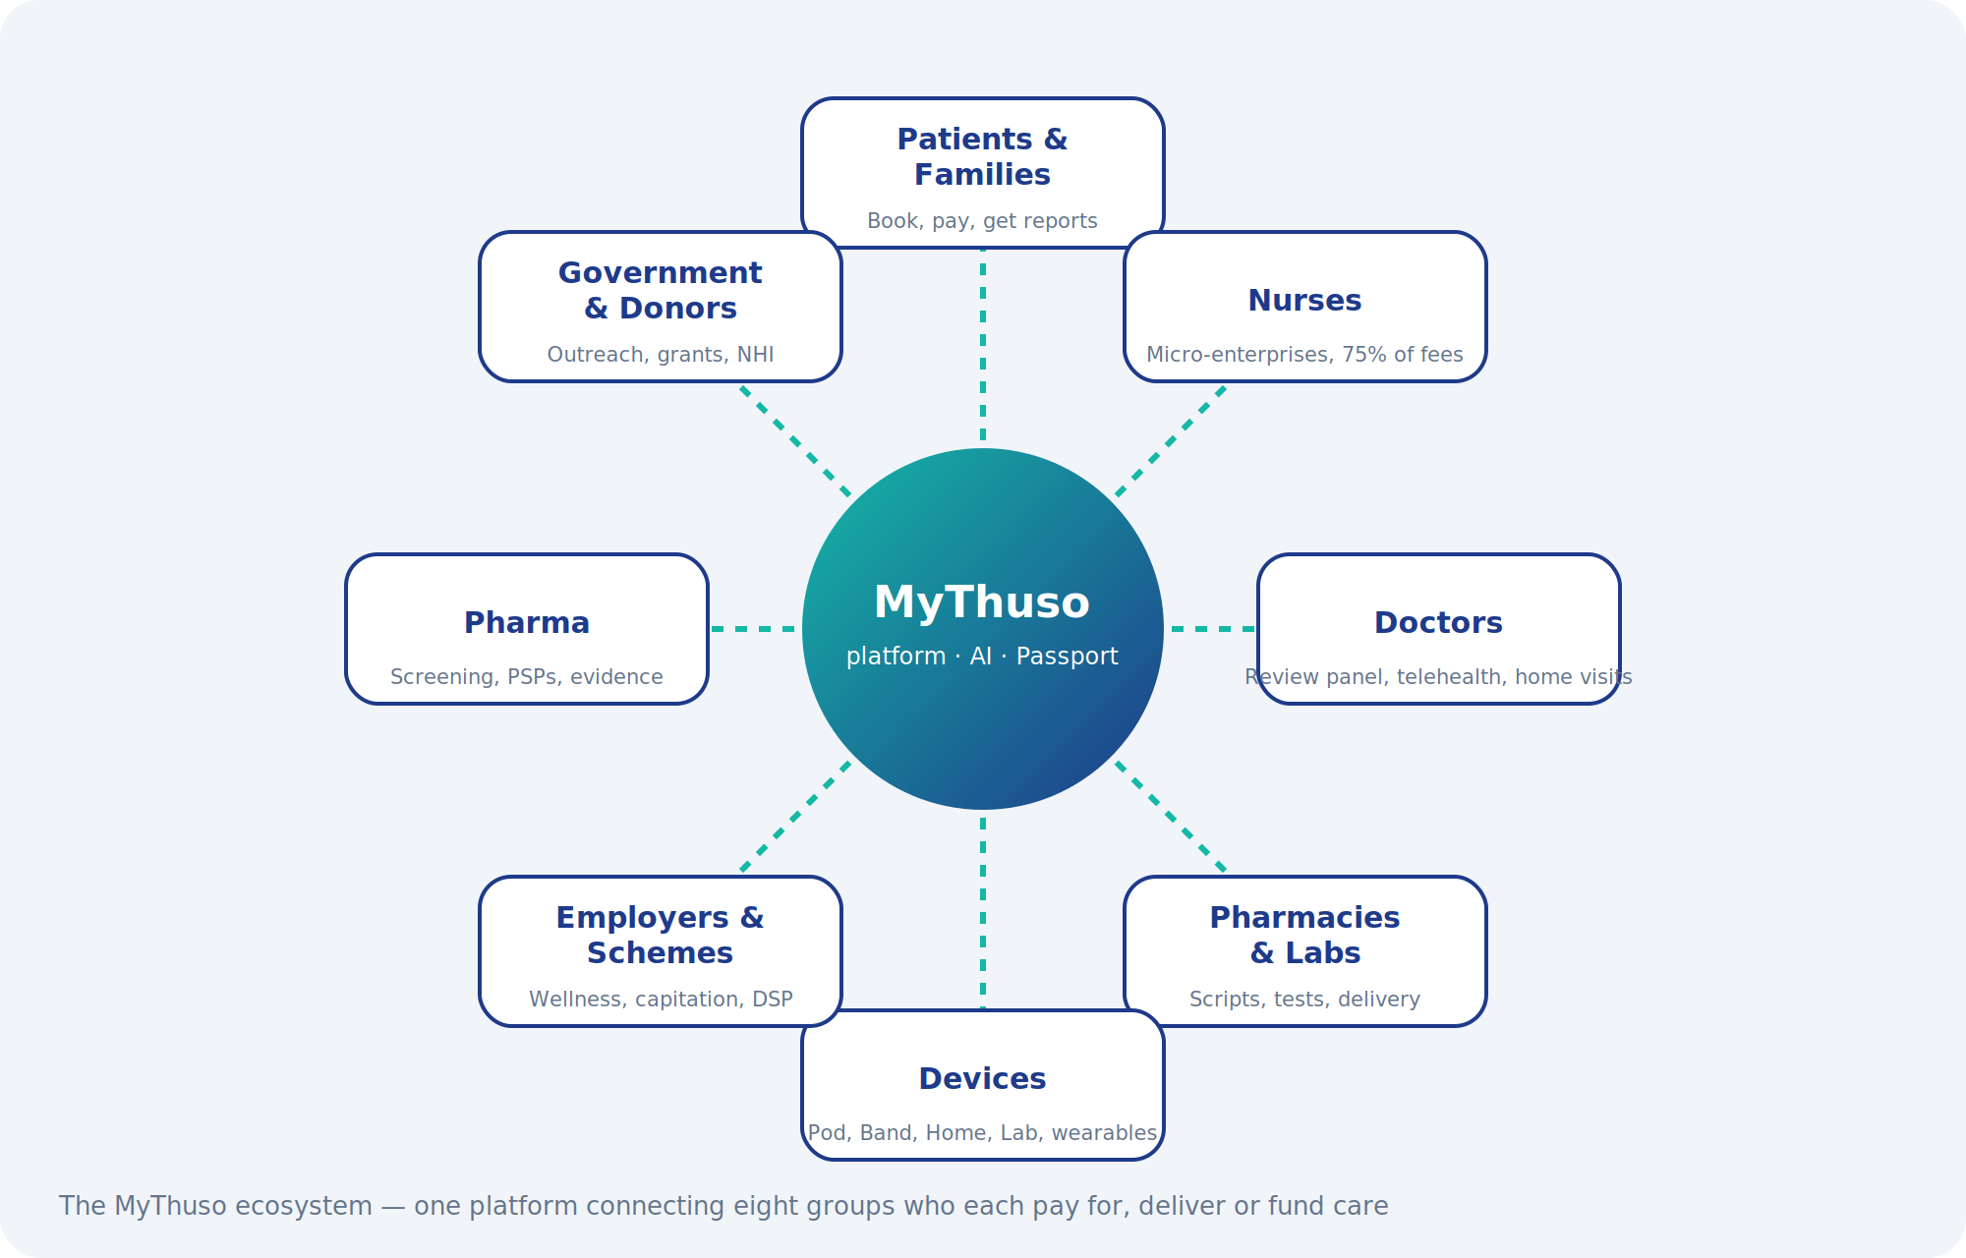

2. Users and personas
Persona | Who they are | What they need from MyThuso
Patient | Adult or child receiving care; often elderly, often without medical aid, often without a smartphone | Simple booking (or booked for them), a trusted nurse, medicines delivered, results explained in their language
Family payer | Son or daughter in the city paying for a parent in a township or village; siblings sharing costs; diaspora | Plans, split billing, live visit updates, reports with photos, doctor flags, one account for several relatives
Registered Nurse | SANC-registered; unemployed, part-time or seeking extra income; often township or rural | Jobs nearby, clear protocols, device that just works, weekly pay, indemnity, documents managed, safety
Enrolled Nurse / Carer | Working under RN supervision from Phase 3 | Supervised tasks, training path, stipend, progression
Doctor | HPCSA-registered; junior, unemployed or private GP wanting extra income | Fast review queue, clean data, prescribing tools, telehealth, per-case pay, indemnity
Pharmacy / Lab | Community pharmacies, courier pharmacies, pathology labs | Orders, e-scripts, sample manifests, result upload, payment
Employer / Scheme / Hospital / School | Institutional buyers | Bulk booking, member management, reporting, invoicing, API
Operations & Clinical Governance | Dispatchers, support, Clinical Lead, Medical Director | Live map, incident queue, vetting, quality, protocols, payouts
Funders & government | Investors, grant bodies, DoH | Outcomes dashboards, job numbers, compliance evidence

3. System overview
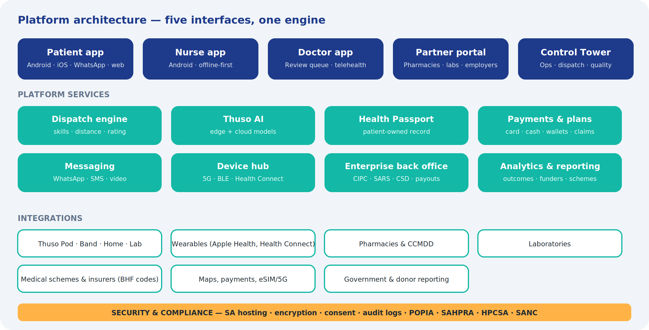
Five interfaces share one engine. All clinical, financial and identity logic lives in platform services exposed through a single API; clients are thin, offline-tolerant and language-aware. Devices connect through the device hub over Bluetooth or directly over 5G/LTE-M. External systems connect through integration adapters with per-partner credentials and audit logs.
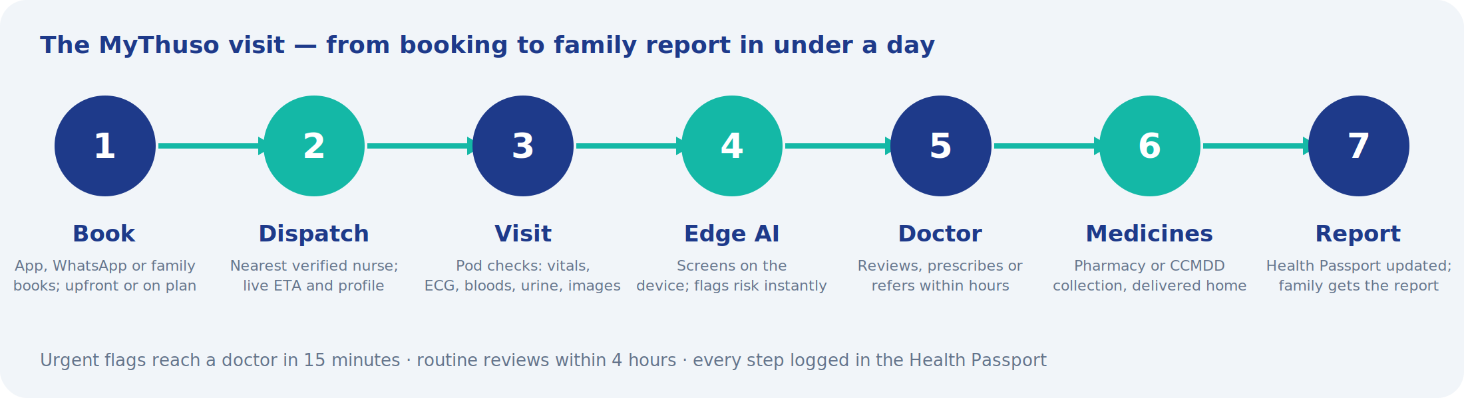

4. Patient & Family app
Android first (the majority of the market), then iOS, with a full web version and a WhatsApp conversational flow for people without the app. Designed for low-end phones, low data, cash and card, and eleven languages.
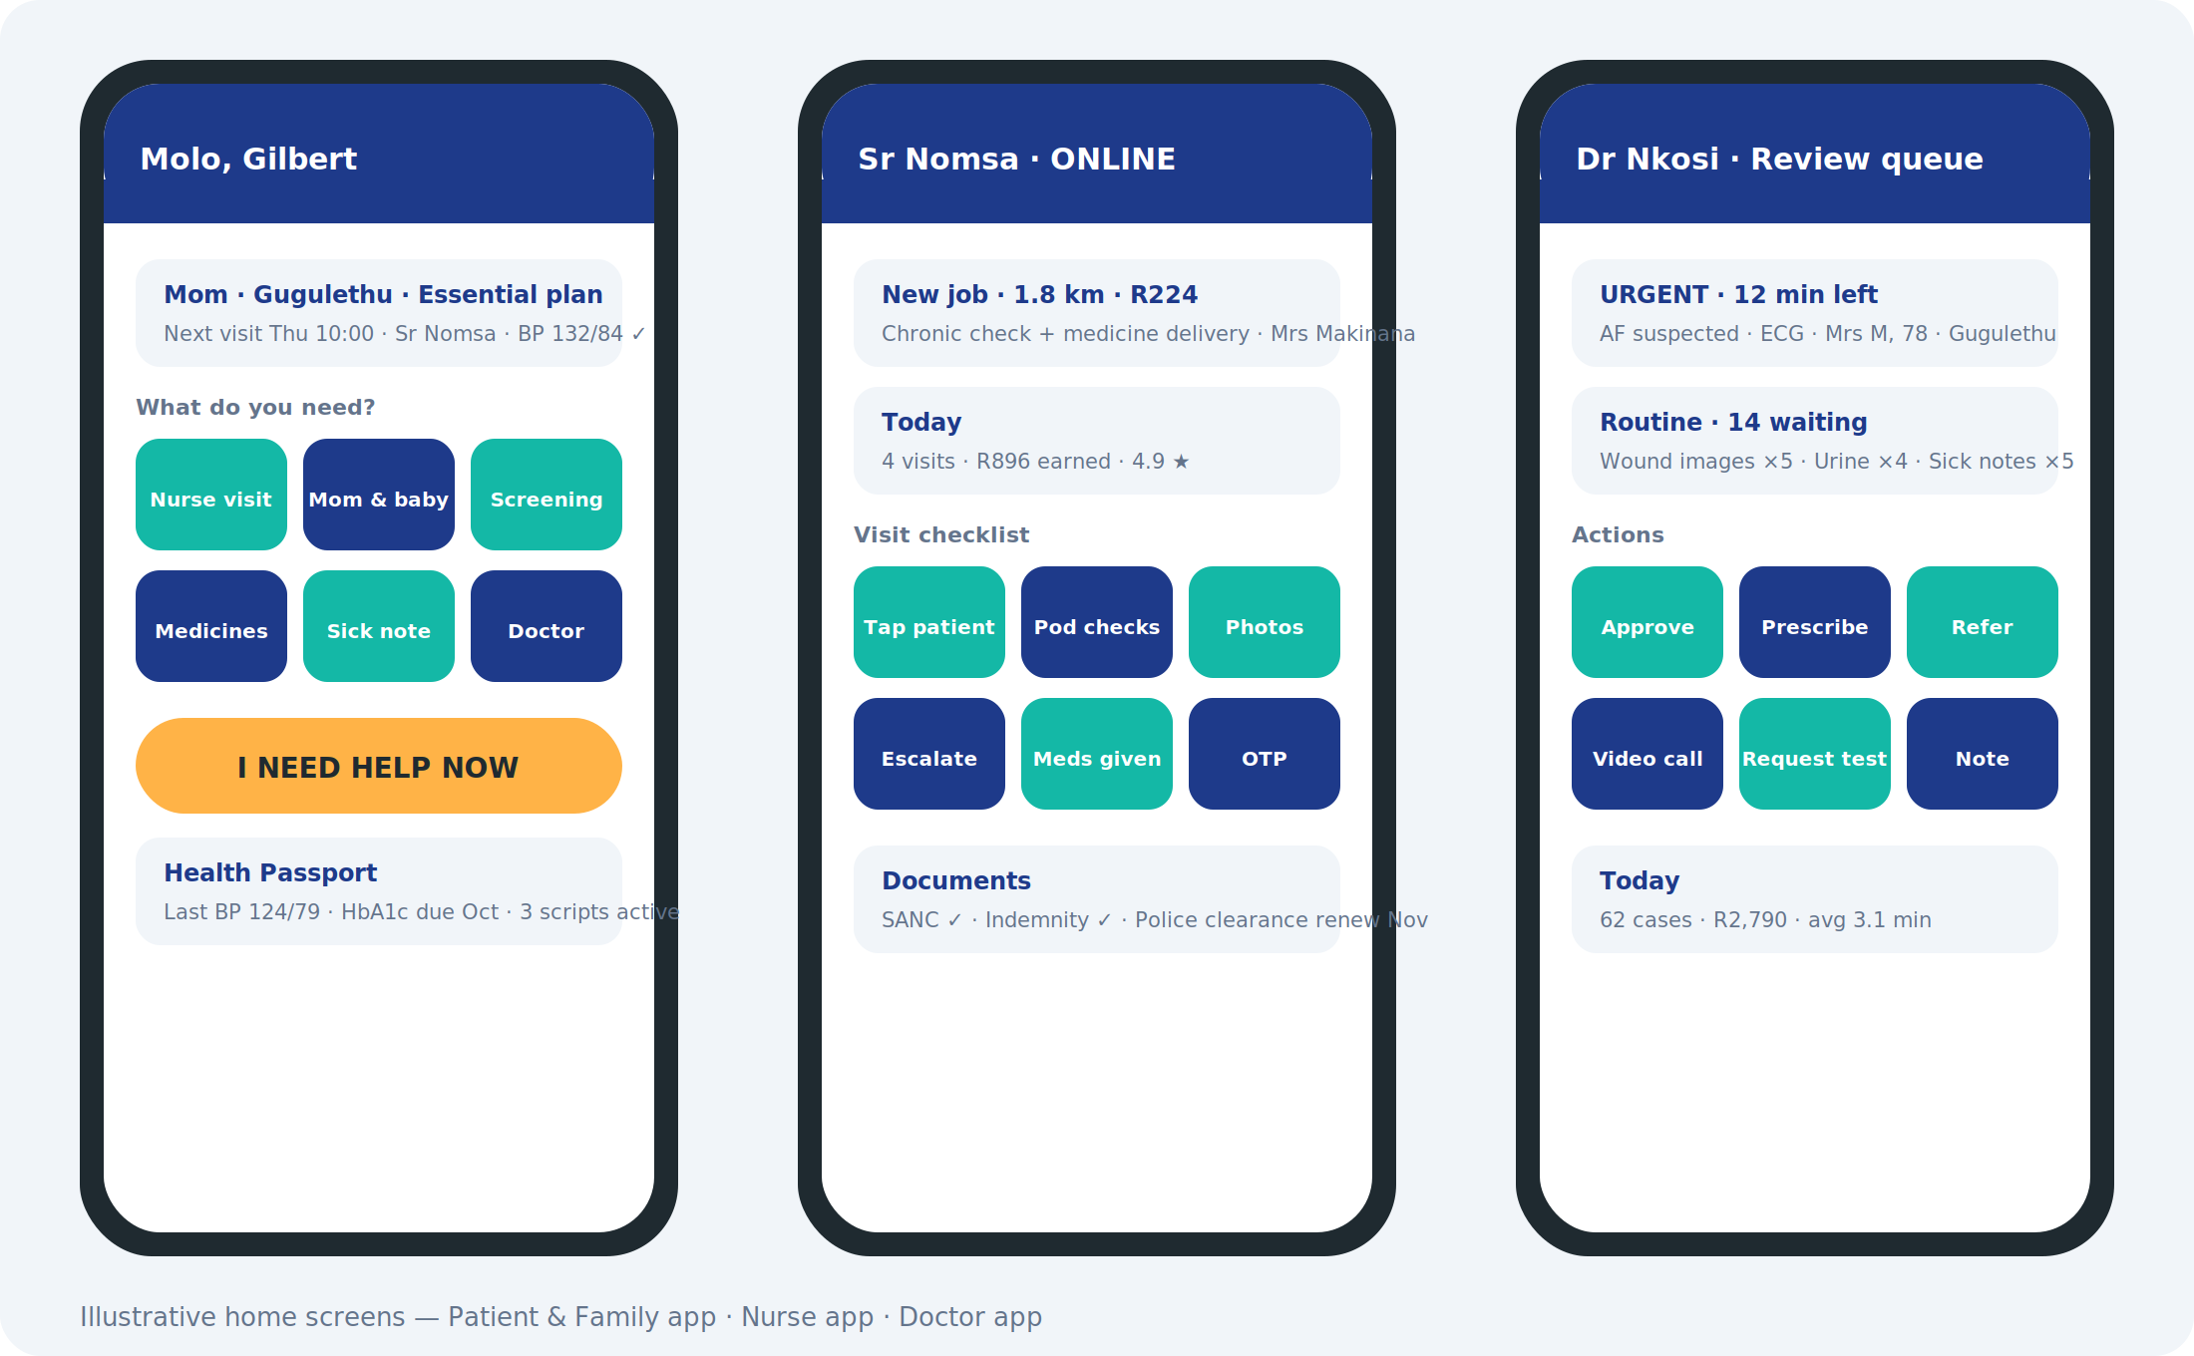

4.1 Onboarding and identity
Feature | Specification | Phase
Phone-number sign-up | OTP sign-up; ID number optional at first, required before clinical services; ID document photo with liveness check | 1
Profile and dependants | Add relatives (parent, child, spouse) with relationship, address, conditions, allergies, medicines, clinic and CCMDD details, preferred language | 1
Consent | Layered POPIA consent per person: treatment, data storage, family sharing, research (optional); revocable; timestamped | 1
Language | English, isiZulu, isiXhosa, Sesotho, Setswana, Sepedi, Afrikaans, Xitsonga, Tshivenda, isiNdebele, siSwati; switchable per screen | 1 (4 languages) / 2 (all)
Accessibility | Large-text mode, screen-reader labels, high contrast, voice prompts for elderly users | 2

4.2 Booking
Feature | Specification | Phase
Service menu | Fixed-price services with plain-language descriptions and what to prepare (script, ID, cylinder of meds) | 1
Book for someone else | Select dependant; address on map with pin drop and landmark description ("blue gate opposite the spaza") | 1
Script upload | Photo of prescription; AI reads drug names and flags controlled substances; doctor confirms | 1
Slot selection | ASAP (dispatch now) or scheduled; recurring for plans; SASSA-day and load-shedding-aware suggestions | 1
Nurse assignment | Preferred nurse, same nurse for plans, female-nurse request; nurse profile with SANC number, rating, badges | 1
Live tracking | ETA, map, driver-style status updates; WhatsApp mirror for family | 1
OTP completion | Patient or family gives OTP to close the visit; photo evidence where appropriate | 1
Thuso SOS | One-tap urgent request; 45-minute promise; doctor on video; escalation to ambulance partner | 2
Symptom triage assistant | AI chat in local languages suggests which service to book; never diagnoses; hands off to nurse or doctor | 2
Photo ordering | Photograph a wound, rash, medicine box or device; AI suggests the right service | 3
USSD and voice booking | *120# menu and voice line in eleven languages for feature-phone users; confirmations by SMS | 1

4.3 Plans and subscriptions
Feature | Specification | Phase
MyThuso for Mom | Essential / Plus / Premium; per-parent; visit cadence, medicine collection, Band and Home options, carer hours | 2
Chronic Routine | Monthly visit, doctor review, CCMDD/pharmacy collection and delivery, adherence nudges | 2
Family Planning Plan | Injection schedule, discreet reminders, private booking | 2
Thuso Mom, Recover, Alert, Cover | Antenatal and baby year; post-discharge; SOS band plan; insurer plan | 3–4
Split billing | Invite siblings; percentage or fixed split; auto-collect; visible contribution history | 2
Plan management | Pause, upgrade, add parent, gift months, payment retries, grace period rules | 2

4.4 Health Passport
Feature | Specification | Phase
Timeline | Every visit, reading, test, script, referral, doctor note and family report in one scrollable record | 2
Vitals graphs | BP, glucose, weight, SpO2, HR trends with doctor-set targets; wearable data merged | 2
Medicine list | Active medicines, doses, refill dates, adherence score, interaction and duplicate checker across all scripts | 2
Referral tracker | Referral letters, public-hospital appointment help, outcome follow-up | 3
Documents | Scripts, sick notes, referral letters, lab reports, certificates — downloadable and shareable by link with expiry | 2
Emergency card | Printable QR for fridge or wallet; opens conditions, medicines, allergies, contacts for paramedics | 2
Sharing | Grant a doctor, hospital or scheme time-limited access; full audit of who viewed what | 3
Export | Full record export (PDF, FHIR bundle) on request | 3

4.5 Family features
Feature | Specification | Phase
Family dashboard | All relatives, next visits, last readings, alerts, spend | 2
Visit report | Sent after every visit: readings, medicines taken, nurse observations, photo, doctor flag, next steps; WhatsApp and in-app | 1
Family video moments | Short nurse-recorded clip of the parent after every visit; video call with the parent through Thuso Home | 2
Alerts | Missed visit, abnormal reading, missed doses, SOS triggered, Band inactivity | 2
Gift a visit | Send a paid visit or screening to anyone by phone number; vouchers redeemable at retail | 2

4.6 Payments
Feature | Specification | Phase
Methods | Card, instant EFT, wallet, cash at door (nurse logs, reconciled), retail vouchers, employer wallet, scheme claim | 1
Wallet | Prepaid balance, top-up by family, stokvel or employer; refunds to wallet | 2
Receipts and statements | Per visit and monthly; scheme-compliant invoices with practice numbers and ICD-10 codes | 2
Pricing engine | Fixed prices, zone surcharges, SOS premium, plan inclusions, promotions, referral credits | 1

4.7 Wearables and devices
Feature | Specification | Phase
Health Connect / Apple Health | Consent-based sync of HR, HRV, SpO2, sleep, steps, ECG, BP trends; mapped into the Passport | 2
Thuso Band | Pairing, battery, SOS test, inactivity and fall alerts to family | 4
Thuso Home | Video consults, pill dispenser schedule, docked device readings, family video calls | 4
Home devices | Bluetooth BP cuff and glucometer readings between visits | 3

4.8 Content, support and settings
Feature | Specification | Phase
Health tips | Condition-specific content in local languages; audio versions; sponsored campaigns clearly labelled | 2
Support | In-app chat, WhatsApp, call-back request; complaint and incident reporting | 1
Notifications | Push, WhatsApp, SMS fallback; quiet hours; per-relative preferences | 1
Privacy centre | View and revoke consents, download data, delete account (with legal retention rules) | 2

5. Nurse app
Android, offline-first, one-hand use, built for a nurse standing in a kitchen with a patient. Every screen is a step in the protocol.

5.1 Onboarding and compliance
Feature | Specification | Phase
Application | SANC number check against the register, ID, police clearance upload, references, indemnity, banking; status tracker | 1
Training | Online modules (protocols, devices, AI workflow, POPIA, safety) with quizzes; practical sign-off by Clinical Lead | 1
Document expiry | Alerts and blocking when SANC APC, indemnity or clearance lapse | 1
Enterprise setup | CIPC, SARS, CSD, bank account and invoicing set up through the app (micro-enterprise programme) | 3

5.2 Working
Feature | Specification | Phase
Go online | Availability toggle, working radius, skills, shift planning; route-based day for Circuits | 1
Job offers | Distance, service, pay, patient notes, time window; accept/decline; auto-assign for plans | 1
Navigation | Maps with landmark notes; contact patient/family; running-late notice | 1
Patient tap-in | NFC card or Band tap, or OTP; confirms identity and opens the Passport | 2
Protocol checklist | Service-specific steps; mandatory fields; device readings auto-filled; photo prompts; notes with voice-to-text | 1
Device capture | Bluetooth BP, glucometer, oximeter, thermometer, scale, ECG; camera reading of urine strips and rapid tests; Pod in Phase 4 | 1–4
Escalate | One-tap escalation to Clinical Lead or doctor with readings and photos attached; emergency numbers | 1
Medicines | Record medicines administered or delivered; scan barcodes; CCMDD collection proof | 2
Completion | OTP, cash logged, patient signature, visit summary auto-generated for the family | 1
Safety | Check-in/check-out timers, panic button, live location shared with dispatch, area risk flags, escort request | 1

5.3 Earnings and growth
Feature | Specification | Phase
Earnings dashboard | Per-visit breakdown, weekly payout, deductions (kit rent-to-own, cash collected), tax summary | 1
Tier and rating | Sisi → Pro → Lead progression; reliability score; customer ratings; badges | 1
Locum shifts | Marketplace for facility shifts; availability calendar | 2
Academy | CPD courses, device training, learnership tracking | 3
Thuso Money and Store | Savings pockets, salary advance, equipment finance, discounted supplies | 3
Referrals | Invite nurses and patients; bonuses | 1

6. Doctor app
Web-first (laptop) with a mobile companion for the review queue and video calls.
Feature | Specification | Phase
Onboarding | HPCSA number check, indemnity, banking, specialties, availability; contract to the review panel | 1
Review queue | Prioritised by AI risk and SLA timer; case view with readings, ECG trace, images, history, AI rationale | 1
Actions | Approve, prescribe (e-script to pharmacy), refer (letter generated), request test, request nurse follow-up, call patient, video call | 1
Sick notes and certificates | Templates compliant with BCEA; QR verification code; employer verification API | 2
Telehealth | Scheduled and on-demand video; waiting room; notes into Passport | 2
Home visits | Job offers and navigation like the nurse app; Pod data on screen | 3
Virtual practice | Patient panel, capitation dashboard, recall lists, chronic care plans | 3
Earnings | Per-case, per-consult, per-visit breakdown; weekly payout | 1
Quality | AI-vs-doctor concordance, peer review sampling, CPD credits for review work | 2

7. Partner portal
Feature | Specification | Phase
Pharmacy | Receive e-scripts and CCMDD collection requests; stock confirmation; pack and hand to nurse or courier; adherence-pack orders; payouts | 2
Laboratory | Sample manifests with barcodes, collection scheduling, result upload (HL7/FHIR or PDF), critical-value alerts to doctor | 2
Employer | Employee roster, wellness-day booking, sick-note verification, wallets, reports | 3
Medical scheme / insurer | Member eligibility check, claims submission with BHF codes, capitation reports, outcomes dashboards | 4
Hospital | Discharge referrals into MyThuso, post-discharge visit tracking, readmission reporting | 3
School / estate / church | Group bookings, screening days, consent collection, results summaries | 3
Government / donor | Programme dashboards: visits, diagnoses, adherence, jobs, spend | 4
API and SSO | Partner API keys, webhooks, single sign-on for large partners | 3

8. Control Tower (operations)
Feature | Specification | Phase
Live map | Nurses, doctors, active visits, SOS, Circuits; filters by zone and status | 1
Dispatch | Auto-assignment rules; manual override; batching for plans and Circuits; surge and shortage alerts | 1
Vetting pipeline | Applications, checks, training progress, sign-off, document expiries | 1
Incident queue | Escalations with SLA timers; Clinical Lead review; root-cause and corrective action log | 1
Quality | Ratings, reliability, protocol completion, AI concordance, complaints; tier changes | 1
Finance | Revenue, payouts, cash reconciliation, refunds, plan billing, partner settlements, grant spend tracking | 1
Clinical governance | Protocol library and versioning, audit trails, adverse-event reporting, regulator packs | 1
Enterprise programme | Micro-enterprise registrations, kit rent-to-own book, grant applications, YES placements | 3
Thuso Line desk | Call-centre and WhatsApp console: book on behalf of families, sell plans, handle complaints, callback queue | 1
Campaigns | Thuso Corner scheduling, sponsored screenings, vouchers, referral programmes | 2
Reporting | Funder, scheme, pharma and government reports; outcome dashboards; data exports | 2

9. Thuso AI
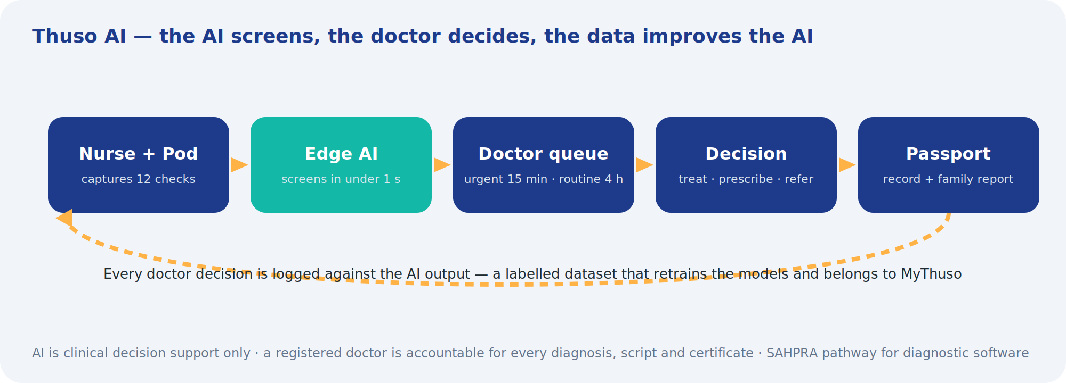
Every model is clinical decision support. Outputs are risk flags, measurements and prioritisation — never diagnoses. A registered doctor reviews every flagged result; every doctor decision is stored against the AI output to build a labelled dataset. Models are versioned, validated on South African data before release, and audited monthly for concordance and bias across sex, age and site.
Model | Input | Output | Source | Phase
Vital-sign risk score | BP, HR, SpO2, temp, RR, history | Early-warning score; trend vs baseline; urgent flag | Own model | 1
Glucose / HbA1c classification | Device readings | Control category; hypo/hyper alerts | Own rules + model | 1
ECG rhythm | Single/6-lead trace | AF, brady/tachy, quality score | Licensed | 2
Wound analysis | Photos with reference sticker | Area, depth trend, infection signs | Licensed → own | 2
Skin lesion triage | Dermatoscope images | Priority for review | Licensed | 2
Urine strip reader | Photo of strip | 10 parameters | Licensed | 2
Rapid-test reader | Photo of cassette | Result with confidence; invalid detection | Licensed → own | 2
Anaemia estimate | Eyelid/nail photo or device | Hb estimate | Licensed | 2
Cough / lung sound | Audio | TB-suggestive pattern, wheeze, crackles | Licensed | 3
Retinopathy | Fundus images | DR grade | Licensed | 3
Growth / nutrition | Weight, height, MUAC, age | WHO z-scores, flags | Own rules | 3
Adherence prediction | Visit, refill, self-report history | Default risk | Own model | 3
Triage assistant | Chat in local languages | Suggested service; red-flag escalation | Own (LLM with guardrails) | 2
Script reader | Prescription photo | Drug names, doses, controlled-substance flags | Own | 1

Governance requirements
- Every AI output carries model version, confidence and rationale visible to the doctor.
- Thresholds set and changed only by the Medical Director with change log.
- Monthly concordance and bias audit; models retrained on consented, de-identified data; SAHPRA pathway for any output with a diagnostic claim.
- Kill switch per model; graceful degradation to manual review.

10. Devices and device hub
Phase 1 uses certified Bluetooth devices; from Phase 4 the platform supports MyThuso's own hardware. The device hub abstracts both behind one interface.
Feature | Specification | Phase
Bluetooth device SDK | Pairing, reading capture, unit normalisation, calibration reminders, battery; supported list managed centrally | 1
Camera capture module | Guided capture (framing, lighting, reference sticker), quality check, secure upload | 1
Thuso Pod integration | 5G/LTE-M direct upload, NFC tap-in, edge AI results, firmware OTA, remote lock | 4
Thuso Band | Continuous streams, event alerts (fall, SOS, inactivity), battery and connectivity monitoring | 4
Thuso Home | Video, pill-dispenser schedules, docked readings, household Wi-Fi management | 4
Thuso Lab | Cartridge results, calibration, consumable tracking | 5
Wearable adapters | Apple Health, Google Health Connect; vendor APIs where needed | 2
Asset management | Every device serialised, assigned, tracked, rent-to-own schedule, loss and damage workflow | 1
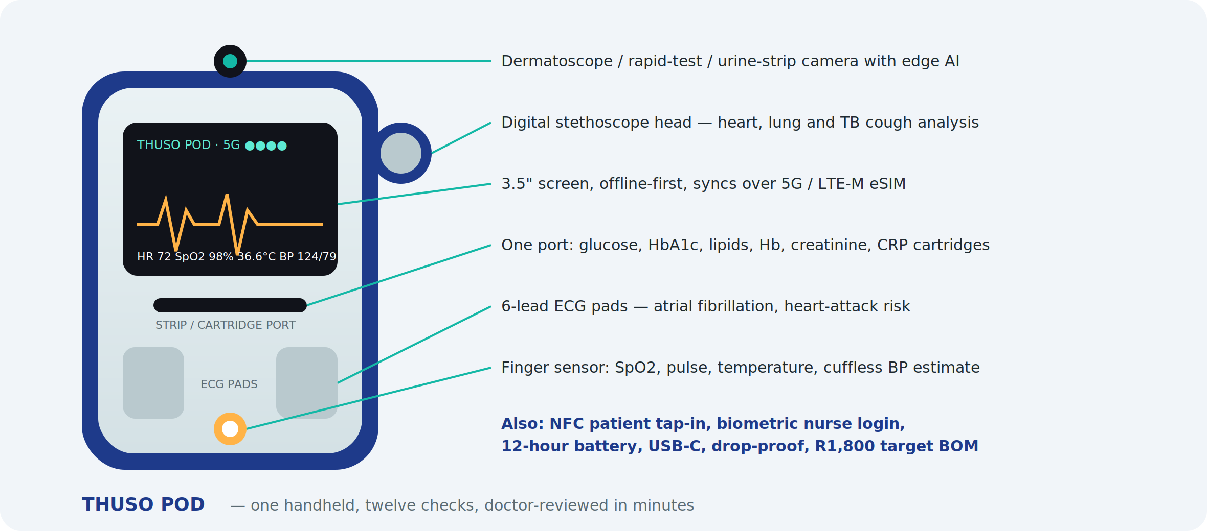
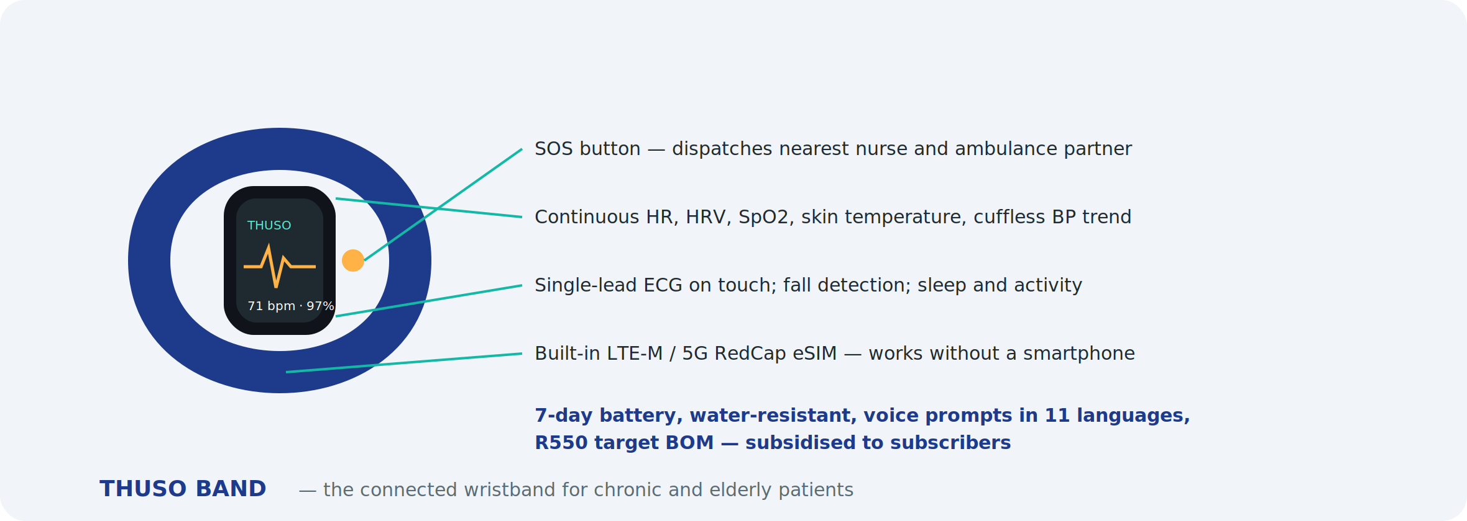

11. Data model (core entities)
Entity | Key attributes
Person | ID, names, DOB, sex, languages, addresses, contacts, consents, relationships, payer links
Provider | Type (RN, EN, carer, doctor, pharmacy, lab), registration numbers, documents, skills, tiers, availability, enterprise details, banking
Service | Code, protocol version, price, duration, required inputs, phase
Visit | Patient, provider, service, schedule, location, status, readings, images, notes, escalations, OTP, cash, rating
Observation | Type, value, unit, device, timestamp, AI outputs, doctor review
Case (doctor review) | Trigger, priority, SLA, decision, prescription, referral, notes, concordance
Prescription / Order | Items, pharmacy or lab, status, delivery, proof
Plan / Subscription | Type, members, cadence, inclusions, billing, split rules, status
Payment / Payout | Method, amount, fees, reconciliation, claims, settlement
Device | Serial, model, owner, assignment, firmware, calibration, rent-to-own
Programme / Contract | Sponsor, scope, beneficiaries, reporting, budget
Audit event | Actor, action, object, timestamp, reason

Standards: FHIR R4 resources for clinical data exchange; ICD-10 and NAPPI codes for claims; SNOMED where partners require; HL7 v2 for legacy laboratory feeds.

12. Payments, billing and claims
Feature | Specification | Phase
Gateways | Card (3-D Secure), instant EFT, wallet, vouchers; tokenised cards for plans | 1
Cash handling | Nurse logs cash, photo of note optional, auto-deducted from payout; limits and cashless incentives | 1
Payouts | Weekly to providers via bulk EFT; instant payout option for fee; statements | 1
Split billing | Multi-payer plans; automatic collection; dunning | 2
Employer and group wallets | Allowances, restrictions, monthly invoicing | 3
Scheme claims | BHF practice numbers, ICD-10, NAPPI, tariff codes, electronic claims via switch, remittance reconciliation | 4
Grants and programmes | Ring-fenced ledgers, beneficiary tracking, audit reports | 3

13. Messaging and notifications
Event | Patient / family | Nurse | Doctor | Ops
Booking confirmed | App + WhatsApp | Job offer | — | Board
Nurse en route / late | App + WhatsApp | — | — | Alert if >15 min
Abnormal reading | After doctor review | Immediate prompt | Urgent queue | Incident if critical
Visit complete | Report + photo | Earnings update | Case created | —
Medicines dispatched / delivered | App + WhatsApp | Delivery task | — | —
Plan renewal / payment failed | App + WhatsApp + SMS | — | — | Finance
SOS | Confirmation + ETA | Priority job | Video call | Live incident
Document expiry | — | 30/7/1-day alerts | Same | Vetting queue

14. Integrations and APIs
- Maps and routing (Google Maps Platform); geocoding tuned for informal addresses and landmarks.
- Payments: card gateway, instant EFT, voucher networks, bulk payouts.
- Messaging: WhatsApp Business API, SMS gateway, push; video via WebRTC provider.
- Pharmacies and CCMDD: order APIs where available; portal and WhatsApp fallback.
- Laboratories: HL7/FHIR result feeds; PDF fallback.
- Schemes: electronic claims switch; eligibility checks.
- Wearables: Apple HealthKit, Google Health Connect.
- Government registers: SANC and HPCSA verification (manual until APIs exist); CSD; SARS e-filing for enterprise programme.
- Public API for partners: bookings, eligibility, reports; webhooks; OAuth2; rate limits; sandbox.

15. Non-functional requirements
Area | Requirement
Security | Encryption in transit (TLS 1.3) and at rest; field-level encryption for identifiers; role-based access; MFA for staff, doctors and partners; secrets management; penetration test before launch and annually
Privacy (POPIA) | Special personal information handling; consent registry; Information Officer; data minimisation; retention schedule; breach process within 72 hours; SA data residency
Availability | 99.9% for core booking and dispatch; degraded offline mode in apps; status page
Offline | Nurse app fully functional without signal for a full day; queued sync with conflict resolution
Performance | Booking to dispatch under 5 seconds; queue load under 2 seconds; image upload resumable
Low-end devices | Android 8+, 2 GB RAM, app under 40 MB, data-light mode
Languages | Eleven official languages; right-sized translations reviewed by clinicians
Accessibility | WCAG 2.1 AA on web; large-text and voice modes on mobile
Auditability | Immutable audit log of clinical and financial actions; exportable for regulators
Clinical safety | Hazard log; safety cases per feature; incident management; change control on protocols and AI thresholds
Scalability | Designed for 10,000 providers and 1 million patients; multi-region within SA

16. Technology stack
- Mobile: React Native or Capacitor (shared TypeScript with web); native modules for Bluetooth, NFC and camera.
- Web: React, TypeScript, Tailwind; Lovable for rapid UI iteration.
- Backend: Node.js/TypeScript services on Postgres (Supabase or managed Postgres), Redis for dispatch state, object storage for images, message queue for sync and notifications.
- AI: Python services; on-device models via TensorFlow Lite / ONNX; licensed vendor APIs behind an abstraction layer; model registry and monitoring.
- Hosting: South African region (Azure South Africa North, AWS Cape Town or local provider); infrastructure as code; separate dev, test, staging, production.
- Observability: logging, tracing, alerting, uptime monitoring; clinical safety dashboards.
- CI/CD: automated tests, static analysis, release approvals for clinical-facing changes; app-store pipelines.

17. Phased delivery plan
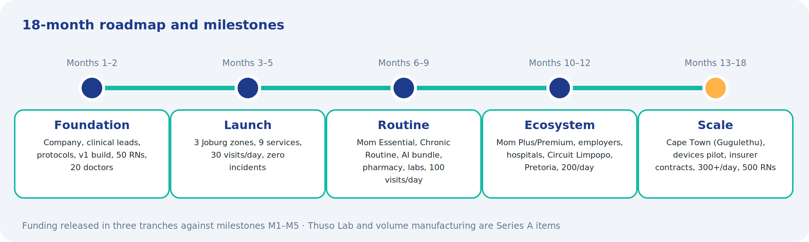
Phase | Months | Scope
1 — Launch MVP | 1–5 | Patient app (Android + web + WhatsApp), Nurse app, Doctor review queue, Control Tower core, 9 services, Bluetooth devices, script reader, vital-sign scoring, payments, visit reports
2 — Routine | 6–9 | Plans (Mom Essential, Chronic Routine, Family Planning), Health Passport, pharmacy and lab portals, telehealth, SOS, triage assistant, wearables sync, locum marketplace, vouchers, ECG/wound/urine/rapid-test AI
3 — Ecosystem | 10–12 | Mom Plus/Premium, Senior features, employer and hospital portals, school and estate bookings, micro-enterprise back office, Academy, Thuso Money, doctor home visits and virtual practice, Circuits, more AI
4 — Scale | 13–18 | Scheme claims and capitation, Thuso Pod/Band/Home integration, insurer plan, programme dashboards, Cape Town and rural expansion, data products
5 — Beyond | 19+ | Thuso Lab, molecular tests, national scale, NHI contracting, export

18. Recommended additional features
Beyond the core, these are the additions I would prioritise because each solves a real South African constraint or opens a revenue line:
Feature | Why it matters | Phase
USSD and voice booking | Millions of parents have feature phones; *120*THUSO# and a voice line in local languages let them book or confirm without an app | 1
Thuso Line call centre | Human dispatchers on WhatsApp and phone for elderly users and family payers; also sells plans | 1
Nurse safety suite | Check-in timers, panic button, trip sharing, area risk map, escort pairing for evening visits; non-negotiable for retention | 1
Load-shedding and weather-aware scheduling | Schedules around known outages and storms; protects device charging and rural routes | 2
Route optimisation for Circuits | Multi-stop weekly routes with time windows and medicine pick-ups | 3
Adherence rewards | Airtime or data rewards for taking medicines and keeping visits; funded by pharma and schemes | 3
Family video moments | Short nurse-recorded videos of the parent after each visit — the emotional core of the family plan | 2
Medicine interaction and duplicate checker | Flags interactions across scripts from clinics, private doctors and pharmacies | 2
Referral letter and appointment helper | Generates referral letters and helps book public-hospital appointments; tracks the referral outcome | 3
Group admin for stokvels and churches | A treasurer manages members, contributions and screening days | 3
Carer marketplace | Bathing, meals, companionship at R120–R180/hour, RN-supervised; expands the Senior offer | 3
Palliative and end-of-life pathway | Hospice partner integration; family support; links to funeral cover | 4
Community health worker mode | Simplified app for CHWs on government programmes, feeding the same Passport | 4
Nurse scholarship and bridging | Sponsored bridging for ENs to RNs; employer and SETA funded | 4
Health passport for children | Road-to-Health card digitised; immunisation reminders; school health records | 3
Emergency ICE sticker | Physical QR sticker at the door and on the fridge for paramedics | 2
Voice-first triage | Spoken symptom description in any language transcribed and triaged | 3
Outcome dashboards for funders | Real-time public impact dashboard: jobs, visits, diagnoses, adherence — a fundraising tool in itself | 2

19. Analytics and KPIs
Area | Metrics
Growth | Visits/day, active patients, plan subscribers, family payers, retention, referral rate
Supply | Active nurses and doctors, utilisation, acceptance rate, time to accept, reliability, earnings per provider
Service | Time to arrival, SLA adherence (urgent and routine reviews), completion rate, ratings, complaints
Clinical | Abnormal findings per 100 visits, referrals completed, adherence scores, readmissions avoided, AI concordance
Financial | GMV, take rate, revenue per stream, CAC, LTV, payout ratio, cash reconciliation variance
Impact | Jobs created, providers previously unemployed, patients diagnosed, screenings done, rural coverage

20. Quality assurance and release
- Clinical features require sign-off by the Clinical Lead (protocol) and Medical Director (AI thresholds) before release.
- Test pyramid: unit, integration, device-in-the-loop tests with real hardware, field UAT with nurses in each zone.
- Staged rollout by zone; feature flags; rollback plan; post-release monitoring of clinical and financial metrics.
- Quarterly security review; annual penetration test; monthly AI audit.

MyThuso — Help. Health. Home.

